**Mathematics Methods Unit 4**

**Test 6**

**Logarithmic Functions, CRV, Normal Distributions and Sampling**

Name: ____________________

Time allowed: 20 minutes Marks: /20

## Section One: Calculator Free

**Show working out where appropriate.**

**Question 1 [2, 2 = 4 marks]**

Evaluate each of the following:

a)  b) 

**Question 2 [1, 2, 3 = 6 marks]**

Use the 68%, 95%, 99.7% rule to give approximate answers to the following.

a) If = 3 and = 2, find

i) P(*X* > 5)

ii) P (*X* < 1 │ *X* < 5)

b) If *X* = 3 has a z score of -2 and *X* = 8 has a z score of 2, find  and 

Question 3 [2 marks]

Sarah was employed to complete a study of a local wren’s population in the Binningup area prior to the building of the new Desalination Plant. During her first visit to the area she captured and tagged 200 local wrens. On her second visit she captured 75 wrens of which 20 had been tagged previously. **Estimate the number of wrens in the area.**

**Question 4 [2, 3, 3, = 8 marks]**

A barrel contains a large number of black and white balls, such that the ratio of black to white balls is 8:2.

The graph below shows the results of a simulation of an experiment in which two balls are randomly drawn from the barrel, the number of black balls noted and then the balls are replaced, for a total of 100 times.



1. Comment on the distribution shown above.
2. Determine the probability that when two balls are randomly drawn from the barrel, both balls are the same colour.

The same simulation is repeated another 100 times, and the proportion of draws in which both balls are the same colour is noted for each simulation.

1. Sketch a frequency histogram to illustrate the likely distribution of these proportions, noting any key features of your sketch.

**Mathematics Methods Unit 4**

**Test 6**

**Logarithmic Functions, CRV, Normal Distributions and Sampling**

Name: ____________________

Time allowed: 35 minutes Marks: /30

## Section Two: Calculator Assumed

**Show working out where appropriate.**

**1 side of A4 notes allowed**

**Calculator allowed**

# 

**Question 5 [1, 3, 3 = 7 marks]**

In a random sample of 275 passenger cars in a city, it was found that 92 had a manual transmission.

1. Estimate the percentage of all passenger cars in the city with a manual transmission.
2. Calculate a 80% confidence interval for the estimate in (a), and briefly explain the meaning of the 80% level.
3. Assuming the estimate in (a) is correct, what size sample of passenger cars, to the nearest 10, would have to be taken in order for the width of a 95% confidence interval to be no more than 0.1?

**Question 6 [1, 2, 4 = 7 marks]**

1. Briefly define a random sample
2. A random sample of Year 12 students was undertaken from which the 90% confidence interval for the proportion of students who planned to take a gap year after finishing Year 12 was determined to be (0.034, 0.252).
3. Explain why the reliability of this interval estimate is not immediately evident.
4. Determine the corresponding 95% confidence interval based on this survey.

**Question 7 [1, 1, 4, 1, 2 = 8 marks]**

A random sample of three items is selected from a batch of 15 items which contains five defective.

a) What is *p*, the proportion of defectives in the batch?

b) What are the possible values of the sample proportion  of defective in the sample?

1. Construct a probability distribution table which summarises the sampling distribution of the sample proportion of defectives in the sample.

**Question 7 cont. next page**

d) Use you sampling distribution to determine the probability that the proportion of defectives is less than 0.4.

e) Find 

**Question 8 [4, 1, 4 = 9 marks]**

The probability of occurrence of a given property is  The simulation of five samples, each of size 50, was conducted, and the mean of each sample is given below.

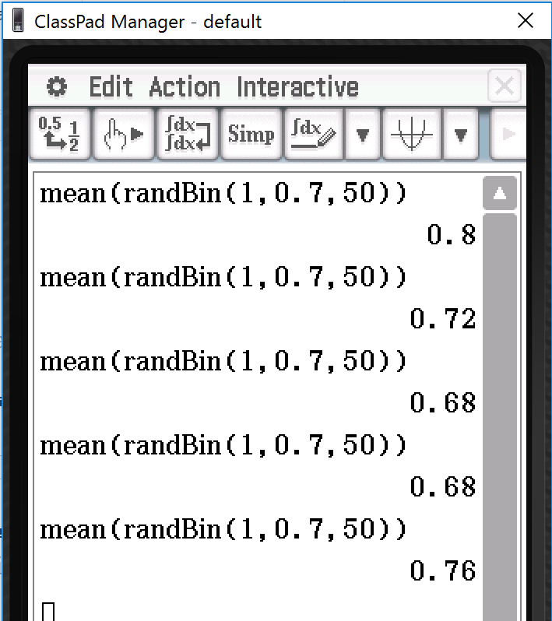

1. Calculate a 90% confidence interval for the first sample.
2. Hence comment on the position of *p* in this confidence interval.
3. Repeat part (a) and (b) for the fourth simulation.